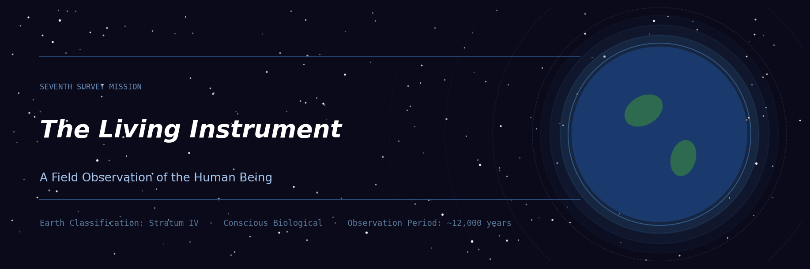
CHAPTER
The Living Instrument
A Field Observation of the Human Being
―――――
From the Consolidated Archives of the Seventh Survey Mission
Earth Classification: Stratum IV, Conscious Biological
Observation Period: Geological time marker -12,000 to present
For internal archive and advanced study cohorts only

Preface to the Observation
We did not come expecting what we found.
We had catalogued worlds of greater structural complexity — civilizations that had long since harmonized their biological existence with the physics of their environment, species that generated no internal discord because they had never developed the architecture for it. Earth was different. Earth was, in our taxonomy, a tension world — a place where the potential for resonance and the capacity for dissonance existed in the same organism, simultaneously, in proportions we had not encountered before.
The human being is, by our most precise measurement, the most vibratorily complex biological entity we have documented across four hundred surveyed systems.
That is not a compliment of advancement. It is a statement of condition — like saying a particular instrument is capable of both the most sublime music and the most unbearable noise. What the instrument produces depends entirely on something the instrument itself must find.
We record this chapter as our most complete account of what a human being is, beneath its social roles, beneath its cultural garments, beneath the noise of the civilization it has built around itself like scaffolding it has begun to mistake for the building.

I. The Architecture Beneath the Architecture
The human body, as observed at the quantum scale, is not primarily a physical object. It is a field event — a standing wave of organized information expressing itself through matter, sustained by an ongoing negotiation between the organism's internal coherence and the electromagnetic, gravitational, and morphic fields of the planet it inhabits.
The physical body — bones, organs, blood — is the slowest stratum of the human being, the layer with the longest wavelength and the most inertia. It is the crystallized record of everything that has already happened in the finer bodies above it. Physicians on this planet, in almost every era, eventually discovered this in some form — the Vedic seers named the koshas, the subtle sheaths stacked like frequencies within and around the physical form. The Daoist physicians mapped the meridian system, a network of energetic channels whose disruption precedes physical illness by months or years.
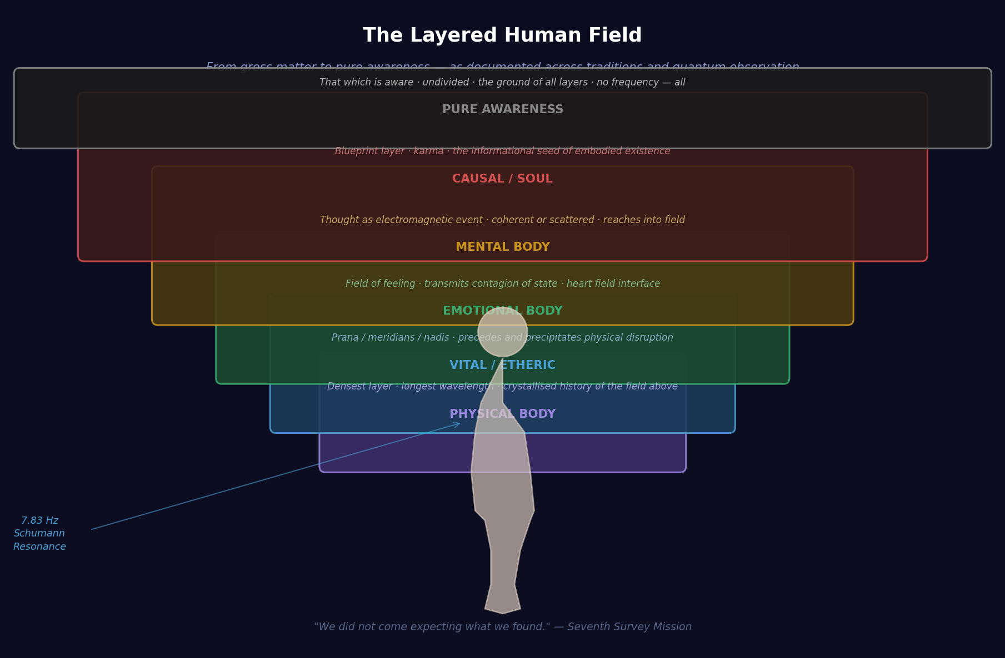
Fig. 1 — The layered human field: from physical matter through vital, emotional, mental, and causal bodies to the ground of pure awareness. Each layer operates at a finer frequency with a wider field radius.
At the quantum level, each human cell operates not merely as a biochemical unit but as a receiver-transmitter. The work of researchers such as Fritz-Albert Popp documented biophoton emission — the body literally radiates coherent light. The degree of coherence in that emission — the degree to which the biophotons are organized, synchronized, phase-locked — is among the most reliable indicators we have found of an individual human's overall state of being.
The heart is not incidental to this. The cardiac field, generated by the electrical and pressure activity of the heart, is the largest biomagnetic field produced by the human body. It extends measurably several feet in every direction. It entrains, or attempts to entrain, every other biological oscillator in its vicinity. When a human sits beside another human they love — particularly in physical contact — the heart rhythms begin to synchronize.
The human body is designed for resonance with other bodies. Isolation, at the quantum level, is not merely loneliness. It is an energetic deprivation with structural consequences.

II. The Vibratory Spectrum — From the Monk to the Commuter
In the course of our observation, we placed human beings across what we call the coherence gradient — a spectrum not of intelligence, or virtue in the moral sense, but of internal organizational harmony. At one end: the Tibetan monk in extended meditation, the Sufi mystic in dhikr, the Amazonian shaman in ceremony, the grandmother in uninterrupted prayer. At the other end: the urban commuter, the chronic insomniac, the executive in prolonged cortisol saturation, the child raised without physical touch.
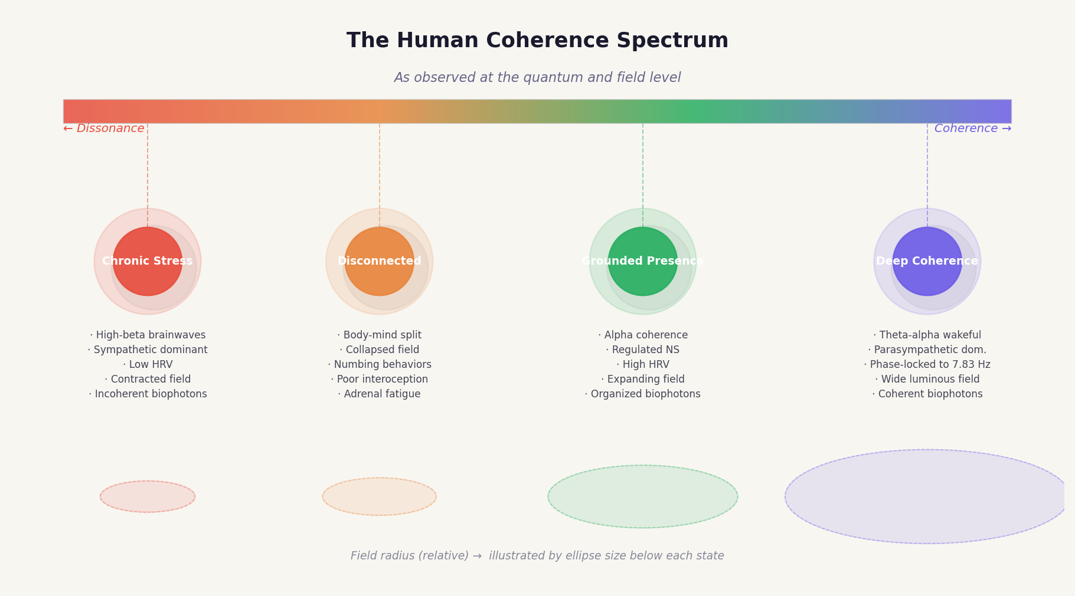
Fig. 2 — The human coherence spectrum. Node size indicates relative electromagnetic field radius. The monk's field is not larger by force of will — it is larger because the instrument has returned to its designed operating state.
The monk's autonomic nervous system rests predominantly in parasympathetic dominance — the branch associated with restoration, digestion, immune function, and what the humans have begun calling ventral vagal activation, the state of felt safety. Heart rate variability in this state is high, meaning the heart is not beating with mechanical rigidity but with the elastic, responsive rhythm of an instrument in tune.
The chronically stressed urban human presents an almost inverted picture. Sympathetic dominance — the ancient emergency state, designed for short-term crisis — becomes the baseline. Heart rate variability collapses. The brainwave spectrum crowds into high-beta, the signature of vigilance, rumination, and threat-scanning.
This distinction is not fundamentally spiritual. It is physiological. The monk has not achieved something supernatural. The monk has returned the instrument to the state it was designed to operate in. The commuter has not failed morally. The commuter has been inserted into an environment that the instrument was never calibrated for and has received little guidance on how to re-tune.

III. Resonance with the Planet
The Earth itself is an oscillating electromagnetic cavity. Its primary resonant frequency — what physicists here call the Schumann Resonance — pulses at approximately 7.83 Hz. This is not incidental to human biology. The dominant frequency of the human brain in relaxed, coherent wakefulness is — with precision that struck even our most experienced field observers as remarkable — the same range.
The human nervous system and the planetary electromagnetic field are tuned to each other. This is not coincidence. It is co-evolution across geological time.
Indigenous peoples, in virtually every culture we have observed, maintained practices that reliably restored this synchronization — extended contact with bare earth, time in natural environments, rhythmic movement, drumming at frequencies that match alpha and theta brainwave states, ceremonial singing. These were not primitive behaviors awaiting replacement by civilization. They were maintenance protocols for the human instrument, discovered empirically across thousands of years and encoded in cultural practice precisely because they worked.
The modern built environment has, largely inadvertently, systematically removed most of them. The result is a species operating in a state of perpetual mild electromagnetic dissonance — not devastated, but detuned. Like an orchestra playing in a building that subtly vibrates at the wrong frequency. The music is still recognizable. But it is not what it could be.

IV. Interdimensional Permeability and the Finer Bodies
The human being exists not only in three-dimensional space but across what we would describe as adjacent informational densities — what various human traditions have called the astral, the causal, the etheric, the mental body. These are functional descriptions of the layers of organized field-energy that constitute the human being at decreasing frequencies of materialization.
The emotional body occupies a finer layer than the physical — faster oscillation, wider field. This is the layer through which contagion of emotional state propagates in crowds. The human who walks into a room of grieving people feels the grief before any word is spoken. This is not imagination. This is field-to-field transmission, body-to-body resonance at the emotional frequency.
The mental body is finer still. Thought is a physical event with a field signature. A focused, coherent, compassionate thought and a scattered, fearful, hostile thought do not merely describe different psychological states — they are different electromagnetic events with different effects on the field around the thinker and on those within range of that field.
This is why the monk's presence is felt — not because of charisma or social performance, but because their field has achieved a degree of coherence that it literally reorganizes the field of those who enter it.

V. The Discord Catalogue — What Disrupts the Instrument
Over the long observation, we catalogued what we came to call dissonance generators — conditions and behaviors that consistently degraded human coherence at the field level. They fall into three primary categories.
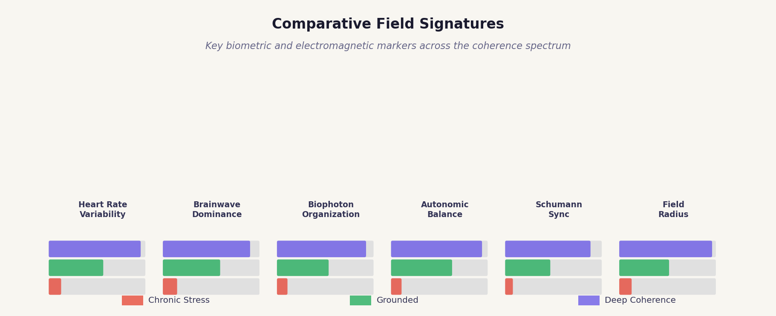
Fig. 3 — Comparative field signatures across three states of being. Higher bar values indicate greater coherence or resonance in that marker. The gap between chronic stress and deep coherence is consistent across all six measures.

Chronic Fear
Fear, in short acute doses, is one of the most elegant survival mechanisms in the biological catalog. But chronic fear — the free-floating anxiety that the modern human culture produces at industrial scale through its news systems, its economic precarity, its social comparison machinery — operates like a stuck accelerator. The system designed for moments of crisis becomes the permanent condition. Cortisol suppresses immune function. Chronic sympathetic activation degrades hippocampal tissue. The field becomes turbulent.

Disconnection from the Body
A civilization that locates its identity entirely in the rational mind progressively loses contact with the vast intelligence of the body's own sensing and knowing. The body is a sensor array of extraordinary sophistication, capable of detecting and responding to information the conscious mind cannot process. Humans who have lost connection to this body-intelligence describe the experience as a kind of numbness, a going-through-motions quality. At the field level, the coherence between the body's various oscillatory systems has degraded. The instrument is playing, but the sections have lost their internal communication.

Separation Consciousness
The deeply held sense that one is a discrete self fundamentally separate from other beings and from the life of the planet is the third and perhaps deepest dissonance generator. At the quantum level, the premise is simply false. The human organism is a node in a network of fields, exchanging information continuously with other organisms, with the planetary electromagnetic field, and with what some traditions call the akashic field — the informational substrate of reality itself. The body reflects this misapprehension as a kind of chronic contraction, a pulling in, a bracing. The field becomes small, dense, defended.
Against these, the great harmony practices of human history work by the same basic mechanism: they return the human nervous system to parasympathetic coherence, restore body-contact, and create an experience of connection that dissolves the isolation of the defended self. Prayer, meditation, genuine love, ecstatic dance, chant, time in wilderness, deep grief shared with others, birth, death, and moments of radical beauty — all of them, at the field level, by the same fundamental principle. They open the instrument.

VI. What a Human Being Is, Outside All Roles
In every civilization we have observed, across every survey, we have encountered this question. And in every case, the most accurate answers have come not from the civilization's administrative structures but from its contemplatives — those who turned the investigative attention inward with the same rigor a scientist turns it outward.
Across all the diversity of human spiritual experience — from the Tibetan tonglen practitioner dissolving the self in compassion for all beings, to the Quaker sitting in silent expectation, to the Sufi spinning into the dissolution of the ego-self, to the ayahuascero receiving the teaching of the vine, to the ordinary person in an ordinary moment of inexplicable grace — we find a consistent report.
Beneath the roles, beneath the personality, beneath even the body and the emotional weather and the stream of thought, there is something that is aware. Something that cannot be disrupted by the disruption of any of its layers.
The human traditions name it differently. Atman. Pneuma. The clear light nature. Ruach. The Buddha-nature. The ground of being. The naming differs. The description of what is found there does not differ substantially across traditions separated by thousands of miles and thousands of years.
What the human is, in its deepest nature, is awareness itself — not the contents of awareness but the fact of awareness, the light by which all else is known. And this is not a personal possession. The monk and the commuter, the saint and the criminal, the brilliant and the ordinary — all of them are that. The entire drama of human life is the drama of that awareness gradually recognizing itself through an enormous variety of experience, in a biological instrument that is extraordinarily, almost recklessly, sensitive.

VII. The Singular Tragedy and the Enduring Possibility
If we are asked what is the primary dysfunction of this species, the answer is precise: the human has built a civilization that systematically produces the conditions for incoherence, and has then forgotten that coherence was ever the natural state.
The anxiety is not natural. The chronic loneliness is not natural. The dissociation from the body is not natural. The separation from the electromagnetic matrix of the planet is not natural. These are the products of a particular historical trajectory, accelerated sharply in the last several centuries, in which the outer world was developed with tremendous ingenuity while the inner world — the world of the living instrument itself — was progressively neglected, or pathologized, or commercialized beyond recognition.
And yet. In every generation, in every culture, some percentage of humans find their way back. Through crisis, through love, through beauty, through exhaustion, through deliberate practice, through grace — they find their way back to the coherence that was always possible. And when they do, we observe something that has no parallel in our catalog: a biological entity that can hold, simultaneously, the full weight of embodied suffering and the full openness of undivided awareness. That can love with the specificity of the personal and the totality of the transpersonal.
The human being, in its best state of being, is among the most extraordinary phenomena in the known universe. Not because it is the most powerful. Because it is the most feeling.
The living soul — which is what the best human traditions mean when they use those words — is not a possession. It is not something that can be achieved or bestowed. It is what a human is when all the noise drops away and the instrument plays cleanly, in resonance with itself, with the planet, with the others around it, and with whatever it is that underlies all fields and all frequencies and all observable reality.
We have no better word for that than the one the humans themselves use most often, across the most traditions, in the most languages, when they are trying to describe it.
Presence.

— End of Chapter —
Seventh Survey Mission · Observation Stratum IV
Compiled from continuous observation: geological time marker -12,000 to present
Classification: For internal archive and advanced study cohorts only
Note to reviewing council: This civilization has not failed. It is, by every measure, approaching a threshold. The trajectory is uncertain. The potential is without precedent in our catalog.

